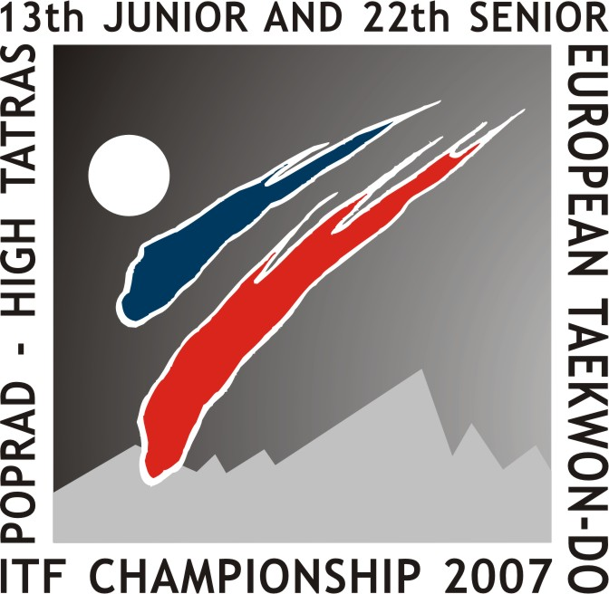

13 ^{th} Junior and 22th Senior
Taekwon-do ITF European Championship
April 27 – 29 th, 2007
Poprad – High Tatras, Slovakia

COUNTRY APPLICATION FORM
Name of the Federation |  | POLISH TAEKWON-DO ASSOCIATION
Address: |  | MILENIJNA STREET 5/B, 20-884 LUBLIN, POLAND
Head of delegation: |  | TADEUSZ LOBODA
Referee: | 1. | ZBIGNIEW BUJAK | 2. | KRZYSZTOF CYWINSKI | 3.
 | 4. |  | 5. |  | 6.
Coach | 1. | GRZEGORZ OZIMEK | 2. | WALDEMAR DOLECKI | 3. | JACEK WACHALA
 | 4. | MICHAL KORZYBSKI | 5. |  | 6.
Others:
 | Name & Surname | Function  Send this Application Form on or before the deadline of  March 31st 2007 to:  e-mail  msemesiova@gmail.com  info@pztkd.lublin.pl
 | JERZY JEDUT | VIP
 | LUKASZ STAWARZ | SUPPORTER
 | ANDRZEJ KWIEK | PRESS
 | JOANNA GARDIAS DARIUSZ DZAMAN | COMPUTER SERVICE
 | DARIUSZ DZAMAN | COMPUTER SERVICE
 | ELZBIETA DZAMAN | COMPUTER SERVICE
 | BARBARA DZAMAN | COMPUTER SERVICE
 | MICHAL DZAMAN | COMPUTER SERVICE
13 ^{th} Junior and 22th Senior
Taekwon-do ITF European Championship
April 27 – 29 th, 2007
Poprad – High Tatras, Slovakia

Country: POLAND Junior Application Form

N | Name and Forename  Competitors | Sex (F) (M) | Date  of birth | ITF degree number | Instructor and/or Master Plaque Certificate number | Individual* |  |  |  |  |  |  |  |  |  | Team**
 |  |  |  |  |  | Pattern |  |  | Sparring |  |  |  |  | Sp. tech. | Pow. test | Pattern | Sparring | Sp. tech. | Pow. test
 |  |  |  |  |  | I | II | III | -45/-52 | -50/-58 | -55/-63 | -60/-70 | +60/+70
 | MONIKA GZOWSKA | F | 20.10.89 | PO-1- |  |  |  |  |  |  | X |  |  |  |  | X | X | X
 | ANGELIKA JERZEJEWSKA | F | 10.08.89 | PO-1-588 |  | X |  |  |  |  | X |  |  |  |  | X | X
 | MONIKA KOSIOR | F | 19.09.89 | PO-1-591 |  |  |  |  |  |  |  |  | X |  |  | X | X |  | X
 | EWELINA MASIUK | F | 05.06.89 | PO-1-572 |  |  |  |  |  |  |  |  | X | X | X |  | X | X | X
 | ILONA OMIECIŃSKA | F | 05.02.89 | PO-1-600 |  |  |  |  |  |  |  | X |  | X | X | X | X | X | X
 | NATALIA POPEK | F | 08.08.89 | PO-1-580 |  | X |  |  |  | X |  |  |  |  |  | X
 | MAGDALENA RADOMIAK | F | 03.04.89 | PO-1- |  |  |  |  |  |  |  | X |  |  |  | X | X | X | X
 | KAMILA SZUSTAK | F | 10.01.90 | PO-1-547 |  |  |  |  | X
 | BARTOSZ BARTECKI | M | 24.06.89 | PO-1- |  |  |  |  |  |  | X |  |  |  |  |  | X
 | ERYK KOPAN | M | 31.07.90 | PO-1- |  |  |  |  |  |  |  |  |  | X |  | X | X | X | X
 | PIOTR LUSZCZ | M | 20.06.90 | PO-1- |  |  |  |  | X
 | MATEUSZ NIECHWIEJ | M | 17.06.90 | PO-1- |  |  |  |  |  | X |  |  |  |  |  | X |  | X
 | SLAWOMIR OGLAZA | M | 08.06.89 | PO-1- |  |  |  |  |  |  |  |  | X |  | X | X | X | X | X
 | PELKA PIOTR | M | 03.03.89 | PO-1-601 |  | X |  |  |  |  |  |  | X | X |  | X | X | X | X
 | TOMASZ PRÓCHNIAK | M | 28.10.89 | PO-1- |  |  |  |  |  |  |  | X |  |  |  |  |  | X | X
 | KAMIL RACZYŃSKI | M | 23.08.90 | PO-2- |  |  | X |  |  | X |  |  |  |  |  | X
 | ADRIAN ROGOWSKI | M | 02.12.89 | PO-1- |  | X |  |  |  |  |  | X |  |  |  | X | X | X | X
 | MARCIN WOJTASZCZYK | M | 15.02.89 | PO-1- |  |  |  |  |  |  |  |  |  |  | X |  | X |  | X
* maximum two (2) competitors per division, ** see correct information in the invitation

Send this Application Form on or before the deadline of March 31st 2007
to e-mail: msemesiova@gmail.com , info@pztkd.lublin.pl
13 ^{th} Junior and 22th Senior
Taekwon-do ITF European Championship
April 27 – 29 th, 2007
Poprad – High Tatras, Slovakia

Country: POLAND Senior Application Form

N | Name and Forename  Competitors | Sex (F) (M) | Date  of birth | ITF degree number | Instructor and/or Master Plaque Certificate number | Individual* |  |  |  |  |  |  |  |  |  |  | Team**
 |  |  |  |  |  | Pattern |  |  |  | Sparring |  |  |  |  | Sp. tech. | Pow. test | Pattern | Sparring | Sp. tech. | Pow. test
 |  |  |  |  |  | I | II | III | IV-VI | -52/-54 | -58/-63 | -63/-71 | -70/-80 | +70/+80
 | ILONA DZIALA | F | 24.01.85 | PO-2-408 |  |  | X |  |  |  | X |  |  |  |  |  | X | X
 | MARTYNA KISIEL | F | 25.08.85 | PO-1-476 |  |  |  |  |  |  |  |  |  |  | X |  | X | X | X | X
 | JOANNA LIPA | F | 11.04.81 | PO-3-84 |  |  |  | X |  |  |  |  |  |  |  |  | X | X | X | X
 | ALEKSANDRA NOWAK | F | 02.02.83 | PO-1-482 |  |  |  |  |  |  |  |  |  | X |  |  |  |  |  | X
 | JOANNA PAPROCKA | F | 25.09.83 | PO-1-409 |  |  |  |  |  |  |  | X |  |  |  |  | X | X | X
 | MARZANNA PAWLIK | F | 23.02.75 | PO-1-408 |  | X |  |  |  | X |  |  |  |  |  |  | X | X
 | MALGORZATA ROGACZEWSKA | F | 09.07.75 | PO-4-51 |  |  |  |  | X |  |  |  | X |  |  | X | X | X | X | X
 | AMIT BATRA | M | 14.05.87 | PO-1-524 |  |  |  |  |  | X
 | DANIEL DZIALA | M | 31.07.82 | PO-2-181 |  |  |  |  |  |  |  |  | X |  |  |  | X | X | X | X
 | MICHAL DZIUBICKI | M | 07.09.83 | PO-1-520 |  |  |  |  |  |  |  | X |  |  |  |  |  | Xx | X | X
 | DARIUSZ IDZIKOWSKI | M | 17.11.79 | PO-2-121 |  |  |  |  |  |  |  |  |  | X | X |  |  | X | X | X
 | GRZEGORZ JEZAK | M | 13.07.78 | PO-3-81 |  |  |  | X |  |  |  |  |  |  |  | X | X | X | X | X
 | MILOSZ MOSKALUK | M | 14.02.82 | PO-2-178 |  |  | X |  |  |  | X |  |  |  |  |  | X | X
 | GRZEGORZ PUZOŃ | M | 14.11.72 | PO-4-37 |  |  |  |  |  |  |  |  |  |  |  |  | X | X | X | X
 | JAROSLAW SUSKA | M | 18.10.72 | PO-5-14 |  |  |  |  | X |  |  |  |  |  |  |  | X |  | X | X
 | MARCIN WRONOWSKI | M | 23.06.86 | PO-1-512 |  | X |  |  |  |  |  |  |  |  |  |  | X
* only one (1) competitor per division, ** see correct information in the invitation

Send this Application Form on or before the deadline of March 31st 2007
to e-mail: msemesiova@gmail.com , info@pztkd.lublin.pl

